

**Operational Procedure for Reservation Reconciliation**

Preferred Hotels & Resorts generates reservation invoices on or about the 10th of each month and distributes them via email (US Mail if requested). Invoicing is based on net confirmed reservations for arrivals within the prior month. Invoices reflect reservations that remain in the system as of midnight on the last day of the month.

This document is best summarized by four letters: **C.A.T.S: Cancel At The Source**

Reservations made through all of Preferred Hotels & Resorts’ distribution channels must be canceled at the original source of the reservation to avoid a booking fee being billed. These channels include the following:

* **Voice Agent** – Call center booking application.
* **Internet Booking Engine (IBE)** for PH&R Brand websites as well as hotel websites, including mobile booking engines.
* **Global Distribution Systems (GDS)** including Amadeus, Apollo/Galileo, Sabre and Worldspan used by travel agents and also powering some online travel agencies programs (OTA’s), such as Orbitz Retail and Priceline Opaque.
* **Internet Distribution Systems (IDS**) to On-line Travel Agencies (OTA’s) primarily for retail rates to most major OTA’s and some OTA merchant programs.
* **Direct Connect (DC) and Channel Connect Express (CCX)** to OTA’s for merchant rates.

Reservations are funneled to SynXis CRS in a one-way direction and they must be canceled at the source (C.A.T.S.) to avoid booking fees*. Cancelling bookings in the hotel’s Property Management System (PMS), or SynXis Central Reservation System (CRS) will not upload and cancel to the external systems of travel agencies (GDS and IDS) regardless of PMS to CRS interfaces. Furthermore, if not cancelled at the source, travel agents will expect a commission as the reservation will appear live in their systems.

*In the case of hotels who have a two-way enhanced PMS/CRS interface with reservation Sync, a reservation that is cancelled in the hotel’s PMS, will also be cancelled/modified in the SynXis CRS. Even in this case, however, GDS/IDS/CCX systems will not be updated and these reservations must also be cancelled at the source (with the travel agent).



**Changes/Cancellation Calls Direct to Hotel**

**GDS/IDS/OTA/DC/CCX Bookings**: Guest calls directly to a hotel reservation center for modifications/cancellation of reservations that originated from a GDS or OTA, should be redirected to the source. If in the interest of customer service, the hotel cancels these reservations from their PMS, they must also assume the responsibility of contacting the travel agency and canceling the booking on the customer’s behalf.

Cancellation after policy deadline: If the hotel determines an exception is warranted and accepts cancellation after the cancellation deadline has passed, the booking may still subject to a booking fee. PH&R also incurs fees for these bookings. The GDS systems are designed to enforce these policies and travel agents also cannot cancel after the deadline has passed*. Please recognize that there is a cost associated to these exceptions. If exceptions are frequent, the hotel should strongly consider altering their policy to reduce their expenses. Please do not re-direct any consumers/travel agents back to PH&R to cancel bookings that are past the cancellation deadline. PH&R will not cancel any bookings past the cancellation deadline and hotels must absorb the fee.

*Cancellation policy note: the SynXis CRS system does allow hotels to configure a cancellation policy to enable a guest to cancel at the source, after the cancellation policy deadline, yet still be subject to a penalty or fee. This will allow a guest or travel agent to cancel within a 72 hour cancellation policy, for instance, to remove the reservation from the system, and open up inventory, yet still be subject to a fee. The hotel must set up operational procedures to review all cancellations and charge fees accordingly.

**Web Booking Engine or Call Center Bookings:** If a hotel needs to cancel or modify a reservation on behalf of a customer that originated from a brand or hotel’s website booking engine or call center (Voice Agent), they should also do so at the original source. Visit the originating brand or hotel website and access the reservation by e-mail and confirmation number. If unknown, the email address and confirmation number may be accessed in the SynXis CRS. For voice reservations, contact the Call Center at 866-990-9491 (see www.preferredhotels.com for list of international numbers). PH&R will not cancel any bookings past the cancellation deadline and hotels must absorb the fee.

*Hotels who have questions or concerns regarding their invoiced booking fees please contact your Preferred Regional Director.



**Preferred Hotels & Resorts Admin Procedures**

To ensure you have accurate reservation information the SynXis CRS has numerous reports you may run On-Demand or Subscribe to review daily activity. The Reservation Reports are designed for daily operational use (i.e. Reservation/Front Office Dept. daily operational checklists, multiple times daily, checking entire weekend on Fridays, etc.) to reconcile the reservation activity in Property Management System against SynXis CRS.

How to Generate a Reservations Report

**Navigational Path = Reports>Reservations>Arrival & Departures**

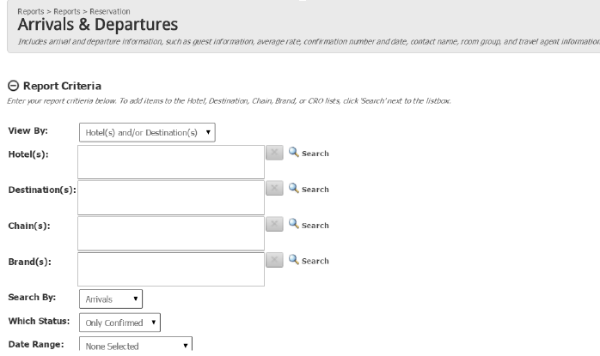



**Navigational Path = Reports>Reservations>New-Modified-Cancel**

